**Data Warehousing and SQL : Assignment 2**

Siddhant Sapte

ALY 6030

CRN: 21008

1. **Identify the dimensions from each dimension table**
2. bed_type

Dimensions: bed_id, bed_code  
Fact: bed_desc

1. business

Dimension: ims_org_id, bed_cluster_id, business_name  
Fact: ttl_license_beds, ttl_census_beds, ttl_staffed_beds

The fact table contains all the information of the keys and the dimension table contains all the information of that measure in the fact table.

1. **Identify the Facts variables from the single Fact Table**

bed_fact

Dimension: ims_org_id, bed_id  
Fact: license_beds, census_beds, staffed_beds

1. **Sketch out a Star Schema using MySQL Workbench**

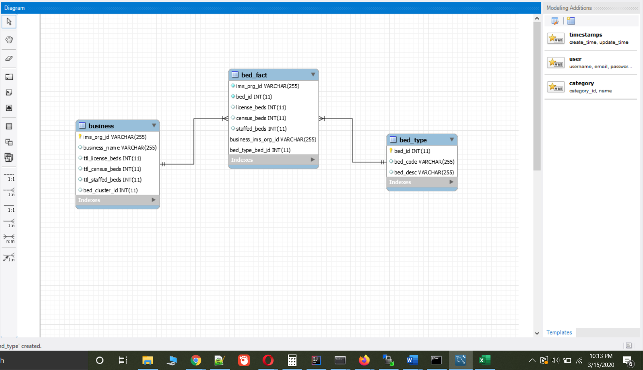

**4a)** **Analysis for Leadership**

-- 1

select b.business_name as Hospital_Name, sum(bf.license_beds) as Total_License_Beds

from business as b

left join bed_fact as bf on b.ims_org_id = bf.ims_org_id

where bf.bed_id =4 or bf.bed_id=15

group by b.ims_org_id

order by Total_License_Beds desc

limit 10;

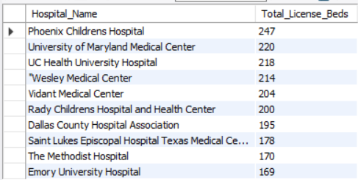

-- 2

select b.business_name as Hospital_Name, sum(bf.census_beds) as Total_Census_Beds

from bed_fact bf

left join business b on b.ims_org_id = bf.ims_org_id

where bf.bed_id =4 or bf.bed_id=15

group by b.ims_org_id

order by Total_Census_Beds desc

limit 10;

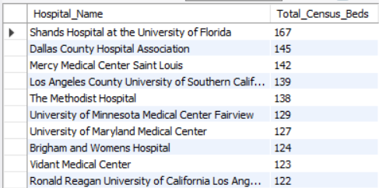

-- 3

select b.business_name as Hospital_Name, sum(bf.staffed_beds) as Total_Staffed_Beds

from bed_fact bf

left join business b on b.ims_org_id = bf.ims_org_id

where bf.bed_id =4 or bf.bed_id=15

group by b.ims_org_id

order by Total_Staffed_Beds desc

limit 10;

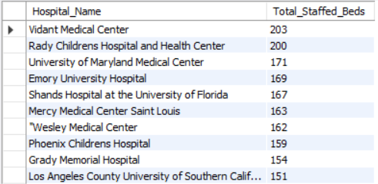

**4b)** **Interpretation of findings**

In this approach I have created new table per the beds, license, census and staffed and then finally merged into one single table. With this we can understand at a glance which table have the maximum tables per bed. From this we also get the other bed capacity with the maximum beds per type.

drop table if exists table_license;

create table table_license

select b.business_name as Hospital_Name, sum(bf.license_beds) as Total_License_Beds

from business as b

left join bed_fact as bf on b.ims_org_id = bf.ims_org_id

where bf.bed_id =4 or bf.bed_id=15

group by b.ims_org_id

order by Total_License_Beds desc;

drop table if exists table_census;

create table table_census

select b.business_name as Hospital_Name, sum(bf.census_beds) as Total_Census_Beds

from bed_fact bf

left join business b on b.ims_org_id = bf.ims_org_id

where bf.bed_id =4 or bf.bed_id=15

group by b.ims_org_id

order by Total_Census_Beds desc;

drop table if exists table_staffed;

create table table_staffed

select b.business_name as Hospital_Name, sum(bf.staffed_beds) as Total_Staffed_Beds

from bed_fact bf

left join business b on b.ims_org_id = bf.ims_org_id

where bf.bed_id =4 or bf.bed_id=15

group by b.ims_org_id

order by Total_Staffed_Beds desc;

drop table if exists table_merged;

create table table_merged

select tl.Hospital_name, tl.Total_License_Beds, tc.Total_Census_Beds, ts.Total_Staffed_Beds from

((table_license as tl

left join table_census as tc on tc.Hospital_Name = tl.Hospital_Name)

left join table_staffed as ts on ts.Hospital_Name = tl.Hospital_Name);

select * from table_merged;

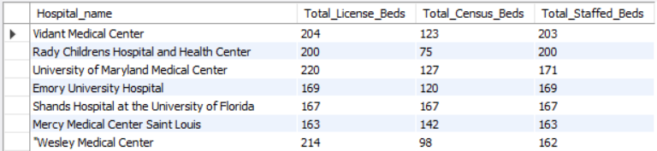

select Hospital_name, Total_License_Beds from table_merged

order by Total_License_Beds desc

limit 3;

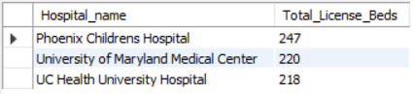

select Hospital_name, Total_Census_Beds from table_merged

order by Total_Census_Beds desc

limit 3;

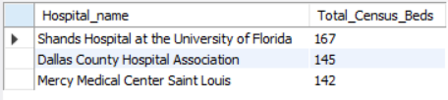

select Hospital_name, Total_staffed_Beds from table_merged

order by Total_staffed_Beds desc

limit 3;

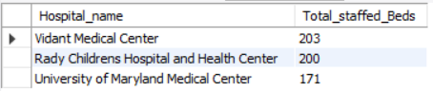

**5a)** **Drill down investigation**

Same approach is followed as per 4a. Here as well the tables are merged into one table, so that we can query it and get the results as per the requirement.

drop table if exists table_license;

create table table_license

select b.business_name as Hospital_Name, sum(bf.license_beds) as Total_License_Beds

from bed_fact as bf

left join bed_type as bt on bf.bed_id=bt.bed_id

left join business b on bf.ims_org_id = b.ims_org_id

where bf.bed_id =4 or bf.bed_id=15

group by bf.ims_org_id

having

count(bf.bed_id)>1

order by Total_License_Beds desc;

drop table if exists table_census;

create table table_census

select b.business_name as Hospital_Name, sum(bf.census_beds) as Total_Census_Beds

from bed_fact as bf

left join bed_type as bt on bf.bed_id=bt.bed_id

left join business b on bf.ims_org_id = b.ims_org_id

where bf.bed_id =4 or bf.bed_id=15

group by bf.ims_org_id

having

count(bf.bed_id)>1

order by Total_Census_Beds desc;

drop table if exists table_staffed;

create table table_staffed

select b.business_name as Hospital_Name, sum(bf.staffed_beds) as Total_Staffed_Beds

from bed_fact as bf

left join bed_type as bt on bf.bed_id=bt.bed_id

left join business b on bf.ims_org_id = b.ims_org_id

where bf.bed_id =4 or bf.bed_id=15

group by bf.ims_org_id

having

count(bf.bed_id)>1

order by Total_Staffed_Beds desc;

drop table if exists table_merged;

create table table_merged

select tl.Hospital_name, tl.Total_License_Beds, tc.Total_Census_Beds, ts.Total_Staffed_Beds from

((table_license as tl

join table_census as tc on tc.Hospital_Name = tl.Hospital_Name)

join table_staffed as ts on ts.Hospital_Name = tl.Hospital_Name);

select * from table_merged;

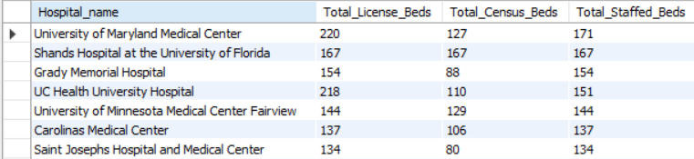

select Hospital_name, Total_License_Beds from table_merged

order by Total_license_beds desc

limit 10;

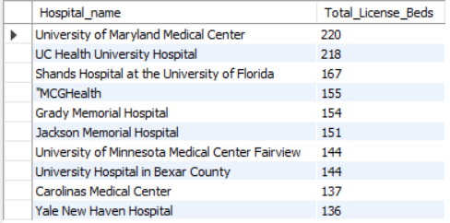

select Hospital_name, Total_Census_Beds from table_merged

order by Total_Census_Beds desc

limit 10;

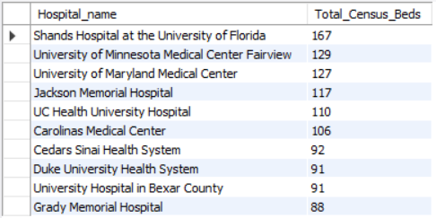

select Hospital_name, Total_staffed_Beds from table_merged

order by Total_staffed_Beds desc

limit 10;

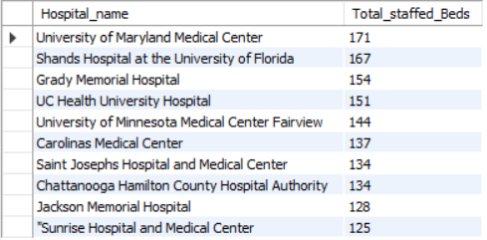

**5b)** **Final recommendation**

From 5a analysis, the hospitals where the staffing is more than the census beds have more efficient outcome as the nurses to patient ratio is more. In such type of hospitals the census beds can be increased, given that they have license for more beds.

University of Maryland Medical Center,  
License beds: 220 , Census Beds: 127 , Staffed beds: 171

Grady Memorial Hospital,  
License beds: 154 , Census Beds: 88 , Staffed beds: 154

So the hospitals such as University of Maryland Medical Center and Grady Memorial Hospital can certainly increase the capacity of the beds as they have more staffed beds. This will be cost effective as they have already more staff and have license to put more bed as well. Grady Memorial Hospital has staff to cover all the license beds and have 88 census beds. They can certainly increase the census beds considering the staff to patient ratio and can serve more people at a time.

**Reference:**

Difference Between Fact Table and Dimension Table. (n.d.). Retrieved from <https://www.guru99.com/fact-table-vs-dimension-table.html>